Exercise 2 - E-commerce Platform Search Function

Steps 1: Understanding Asymptotic Notation –
- Explain Big O notation and how it helps in analyzing algorithms.

Big O notation describes how an algorithm's running time (or memory use) grows as the size of its input, n, grows, ignoring constant factors and lower-order terms. It gives an upper bound on the worst-case growth rate, which lets us compare algorithms independently of the hardware they run on. For example, an algorithm that is O(n) will, in the worst case, take roughly twice as long if the input doubles, while an O(log n) algorithm barely slows down at all as n grows — which is exactly the difference between the two search methods used in this exercise.

- Describe the best, average, and worst-case scenarios for search operations.

For a linear search, the best case is O(1) — the target is the very first element checked. The average case is O(n) — on average the search scans through about half of the list before finding (or ruling out) the target. The worst case is also O(n) — the target is the last element, or isn't present at all, so every element must be checked.
For a binary search on a sorted list, the best case is O(1) — the target happens to be the middle element on the first comparison. The average and worst cases are both O(log n) — each comparison eliminates half of the remaining search space, so even a catalog of a million products needs only about twenty comparisons in the worst case.

Step 2: Setup –

- Create a class Product with attributes for searching, such as productId, productName, and category.

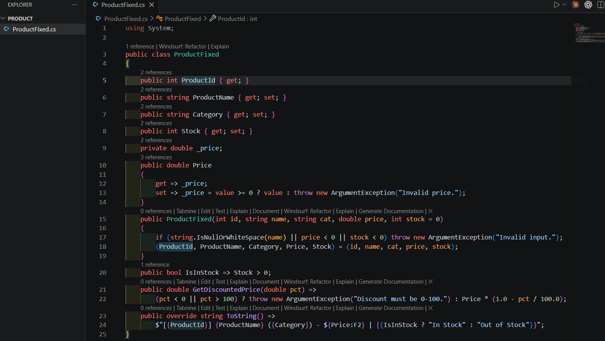

A ProductCatalog class wraps a list of these products and exposes a method to keep the list sorted by name, which is the prerequisite for binary search:

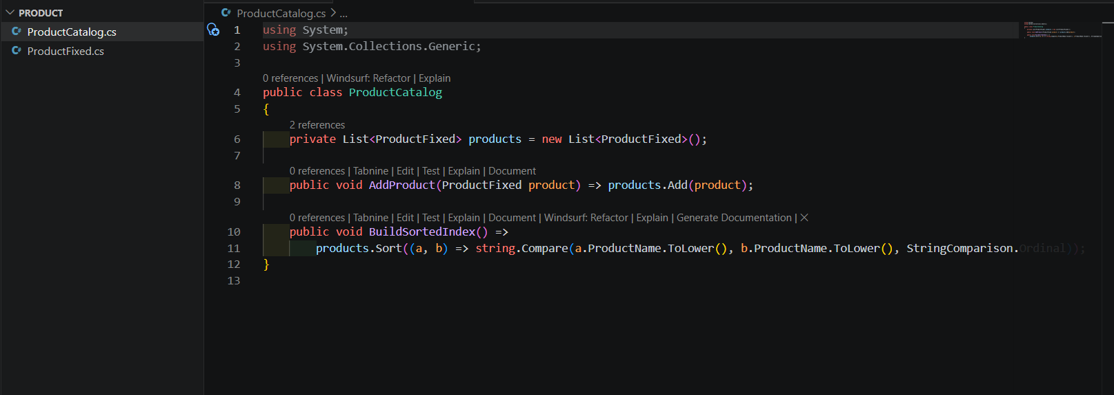

Step 3: Implementation -

- Implement linear search and binary search algorithms.

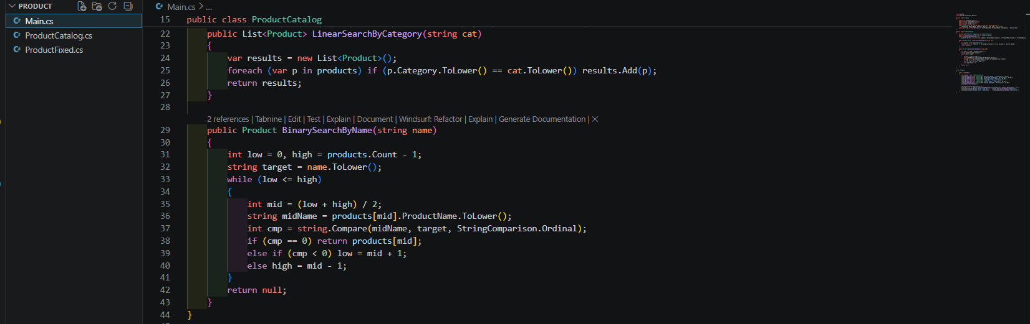

- Store products in an array for linear search and a sorted array for binary search.
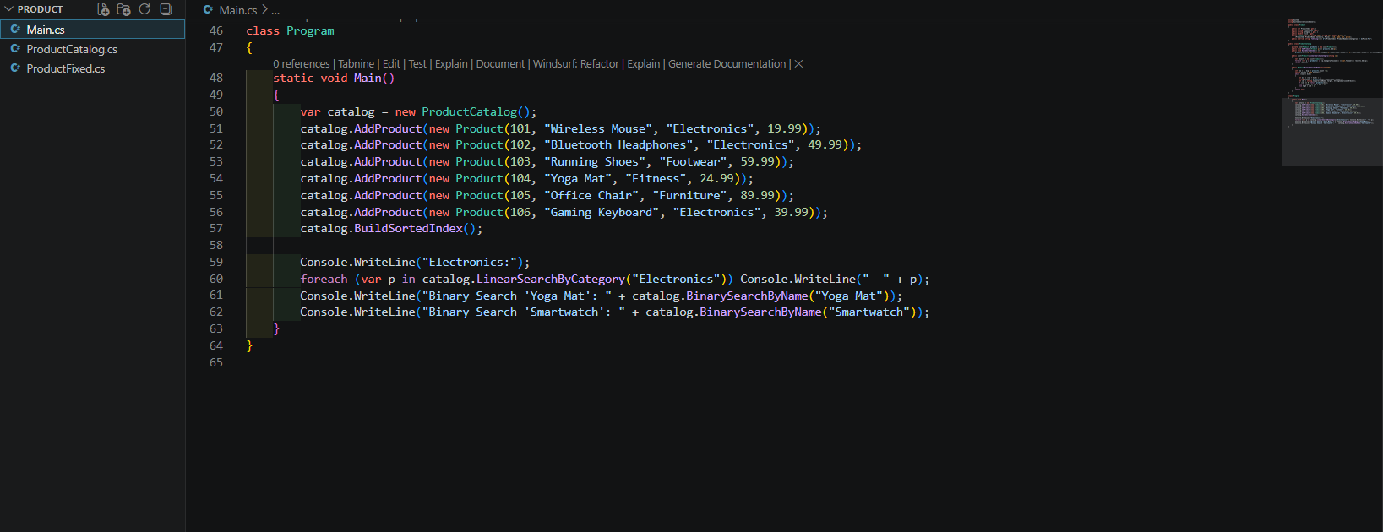
CODE Output:

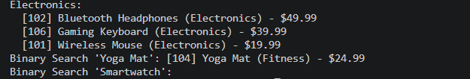

Step 4: Analysis –

- Compare the time complexity of linear and binary search algorithms.

linear_search_by_category() is O(n): it must inspect every product to be sure it has found all matches, since matching items can be scattered anywhere in the array.
While binary_search_by_name() is O(log n): each comparison against the middle element eliminates half of the remaining candidates, so the number of comparisons grows only logarithmically as the catalog gets larger — for a catalog of 1,000,000 products, linear search may need up to a million comparisons, while binary search needs at most about 20.

- Discuss which algorithm is more suitable for your platform and why.

Neither algorithm is universally “better” — they solve different problems. Linear search is the right tool for category browsing, because the platform needs every matching product and category isn't the field the array is sorted by; a binary search can't be used here without maintaining a separate sorted index per category. Binary search is the right tool for exact-name lookup (e.g. an autocomplete or “jump to product” feature), because there is exactly one match to find and the catalog is already sorted by name. In practice, an e-commerce platform would keep the catalog array sorted by name for fast lookups, while still supporting full linear scans (or, at larger scale, a category index) for browsing — using the right search for the right access pattern is what keeps a growing catalog both flexible and fast.

